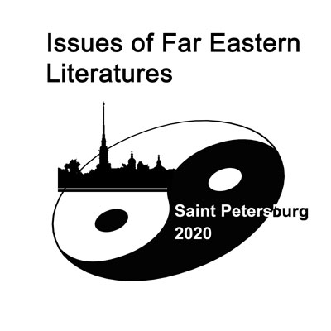
«ISSUES OF FAR EASTERN LITERATURES»
Dedicated to the 380th anniversary of Pu Songling

(Saint Petersburg, June 27 – 29, 2020)

申请邀请信的信息表 （请用英文填写！）
Application for Visa Support (Please, fill in English)

Family name / surname 姓:
Given name(s)名:
Date of birth (DD/MM/YYYY) 出生日:
Previous names, given names,
date of birth if applicable 前用姓名
Country of birth 出生国家:
City of birth 出生城市:
Citizenship status 国籍:
Place of current residence (country, state, city)
常驻国家和城市:
Place of employment / study (full name of the company/university, name of the faculty / department)工作单位:
Position held 职务:
Work / University address: (building number, street, postal code, city, country) 单位地址（国家，邮编，城市，大街，楼号）
Home address (building number, street, postal code, city, country) 常住地址（国家，邮编，城市，大街，楼号）
Contact e-mail 电子信箱:
Contact phone number(s), including country code and city code联系电话:
Russian Embassy or Consulate in your country* that will processes your entry visa application 对哪一家俄罗斯使馆提交申请签证:
Embassy / consulate location (Country) 使馆所在国家:
Embassy / consulate location (City)使馆所在城市:
The address of the intended stay 在圣彼得堡的地址

- Please, return the filled form together with a scanned copy of your passport’s front-page by March 31, 2020 to fareastlit@gmail.com
请把与会者的信息表以及护照照片页的扫描件在2020年3月31日以前寄到fareastlit@gmail.com
- Please, note that the visa support will cover the period from June 24 till July 2, 2020.
请注意，组委会提供的邀请信只涵盖着6月24日至7月2日的时段。
- If you will apply for the Russian visa in a country other than your country of citizenship, please, send us the scan of a document, explaining the reason for that (for example, residence permit, or work visa)
如果您申请的地点不同与您的国际，请提供相关说明文件（如国外工作签证、居留证等）的扫描件。

